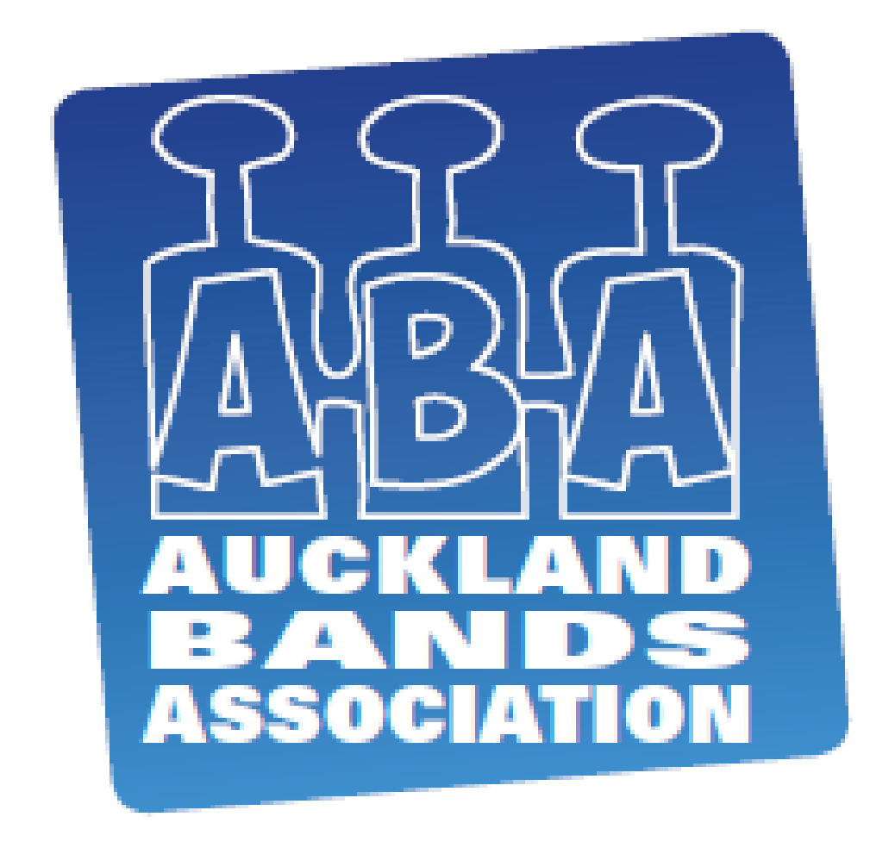
AUCKLAND BANDS ASSOCIATION

YOUTH SECTION CONTEST
HAWKINS THEATRE
13 RAY SMALL DRIVE, PAPAKURA
Sunday, 18th October 2015

ENTRY FORM

Name of Band:
Contact Name: |  | Phone No.:
Postal Address:
Email address: |  | Conductor:
Please identify the following:
Soloist name: |  | Instrument:
Compare name:

Helper: |  | Phone No.:

Yes, the band would like to use the audio visual equipment of the centre

Each band is required to provide the order of their programme to the contest manager, via email (k.v.mcdonald@xtra.co.nz), no later than Friday, 9th October 2015 so it can be included in the programme.
Entry fees: $100+GST ($115) per band.

Band declaration:
We have read and understand the rules of the Auckland Band Association Youth Contest. Our band accepts these rules and agrees to abide by them.

Signed on behalf of the band ______________ _ __ Date ____ / ____ / ____

Payment can be made by:-
- Cheque payable to Auckland Band Association and included with your mailed entry.
- Online to ABA Bank Account 12-3087-0120526-00

ENTRIES CLOSE ON SUNDAY 27th SEPTEMBER 2015
LATE ENTRIES WILL NOT BE ACCEPTED

Entry form, fee and scores to be sent to
Contest Manager, PO Box 5219, Wellesley Street, Auckland, 1141

